Mecklenburg Correctional Center – Building 2 (Red) Room1212
Lesson Handout - December 23, 2006
Prophecy - Daniel Chapter 7 and the Little Horn Power – Part 1

Two weeks ago we studied Daniel chapter 2. We learned about the great metal man image King Nebuchadnezzar saw in a dream, and then Daniel interpreted the dream to him. We understood it to prophesy in advance the 3 successive ruling world empires that would follow Babylon – the head of gold, which was in power at the time of the dream, Medo-Persia – the chest and arms of silver, Greece – the thighs of brass and finally Rome – the legs of iron. Then the breakup into 10 nations represented by the feet of iron and clay. The image is then struck on the feet by a stone, which represents the second coming of Jesus. That dream in 603 BC, over 2,600 years ago, when Daniel was a youth, accurately predicted the future in advance. We are now living in the toes of that dream’s interpretation.

Today we will be looking at history from another perspective and expand on what was foretold in this great prophecy of Daniel chapter 7, written around 555 BC when Daniel was about 70 years old.

We will also be laying a foundation that will eventually reveal who the beast of Revelation 13 is, and the fearful warning in Revelation 14:9,10 against receiving the mark of the beast. You do not want the mark of the beast, as those who receive it will endure the 7 last plagues and be lost. Sadly, most of the Christian world will receive it, because they have failed to study God’s word.

Before we start we must understand that the Bible will interpret itself. Since much of Daniel and Revelation are books that complement each other and are both filled with symbolism, we will use scripture to give us the meaning of some of those symbols.
“Winds” in prophecy represent war, strife, commotion, etc. example: "winds of war" (See Jeremiah 25:31-33; 49:36, 37; 4:11-13; Zechariah 7:14).
“Waters” in prophecy represent existing inhabited areas, people, and populated nations. (See Revelation 17:15)
A “beast” in prophecy represents a kingdom, a government, or a political power. (See Daniel 7:17, 23)

That said; let’s begin with the first three verses of Daniel chapter 7.

“In the first year of Belshazzar king of Babylon (555 B.C.) Daniel had a dream and visions of his head upon his bed: then he wrote the dream, and told the sum of the matters. Daniel spake and said, I saw in my vision by night, and, behold, the four winds of the heaven strove upon the great sea. And four great beasts came up from the sea, diverse one from another.”

What Daniel saw was four kingdoms or empires (which is the symbolic meaning of the 4 beasts) that came up in populated areas, (the symbolic meaning for the sea), the result of significant battles or wars (symbolically represented by the winds). We will see how this prophecy parallels the metal man image of Daniel chapter 2.

What was the first beast like? Verse 4
“The first was like a lion, and had eagle's wings: I beheld till the wings thereof were plucked, and it was lifted up from the earth, and made stand upon the feet as a man, and a man's heart was given to it.”

Wings in prophecy denote speed, great haste. (See Habakkuk 1:8.) This beast, a lion with eagle’s wings, represents the first world kingdom, Babylon, and the speed, which propelled it to power. The parallel kingdom was the head of gold in Daniel chapter 2. Babylon ruled the world from 606 BC to 538 BC. The lion is the king of beasts just as gold is the chief of metals.

Now what was the second beast like? Verse 5
“And behold another beast, a second, like to a bear, and it raised up itself on one side, and [it had] three ribs in the mouth of it between the teeth of it: and they said thus unto it, Arise, devour much flesh.”

The second beast, the bear, represented the Medo-Persian Empire that ruled the world from 538 BC to 331 BC. The Bear was raised up on one side to denote the fact that the Medes were the weaker of the two. The three ribs in its mouth represented the three nations they conquered to come into power, Lydia, Babylon and Egypt. The parallel kingdom was the chest and arms of silver in Daniel chapter 2.
What then was the third beast like? Verse 6
“After this I beheld, and lo another, like a leopard, which had upon the back of it four wings of a fowl; the beast had also four heads; and dominion was given to it.”

This leopard represented the third world empire, Greece. The four wings represented the great speed with which Alexander the Great conquered the world. Greece ruled the world from 331 BC to 168 BC. The four heads represented the four generals to which the kingdom was divided after the death of the young Alexander. They were Cassander, Lysimachus, Seleucus, and Ptolemy. (See note – bottom of page 3) Alexander was only 23 when he overthrew the Persian empire, but died 8 years later from a fever caused by a drunken debauch. The parallel kingdom was the thighs of brass in Daniel chapter 2.

So far we have been studying three of the four beasts (kingdoms) that came up out of the sea (existing populated areas). There was Babylon, verse 4, the lion with eagle’s wings; Medo-Persia, verse 5, the bear; and Greece, verse 6, the 4 winged and 4 headed leopard.

Now we will look at the fourth dreadful beast in verses 7 and 23.
Verse 7. “After this I saw in the night visions, and behold a fourth beast, dreadful and terrible, and strong exceedingly; and it had great iron teeth: it devoured and brake in pieces, and stamped the residue with the feet of it: and it [was] diverse from all the beasts that [were] before it; and it had ten horns.”
Verse 23. “Thus he said, The fourth beast shall be the fourth kingdom upon earth, which shall be diverse from all kingdoms, and shall devour the whole earth, and shall tread it down, and break it in pieces..”

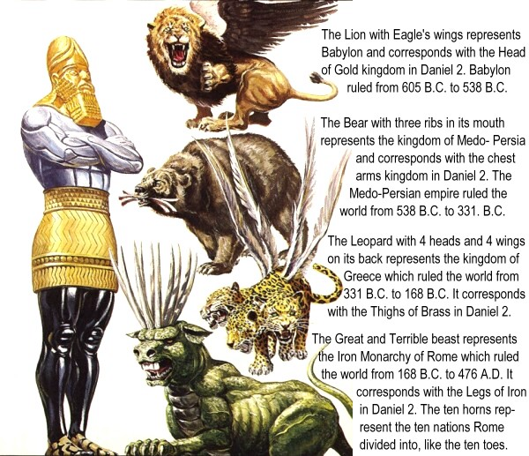
The fourth beast with the terrible iron teeth was the fourth and last kingdom to rule the world, the iron monarchy of Rome. In Daniel 2, the beast was represented by the iron legs. Rome ruled the world from 168 BC to 476 AD. Jesus was born during the rule of the Roman Empire. Notice that verse 7 says it was different from all the beasts that were before it and that it had ten horns. Let’s look at verse 24 for some understanding of the ten horns.

Verse 24. “And the ten horns out of this kingdom are ten kings that shall arise:”
The ten horns were the ten toes of Daniel 2. After the fall of the Roman Empire, the ten tribes from the north became the ten kingdoms. The ten nations were: The Alemanni, (Germany); the Franks, (France); the
Bergundians, (Switzerland); the Suevi, (Portugal); the Anglo-Saxons, (England); the Visigoths, (Spain); the Lombards, (Italy); the Heruli, the Vandals and the Ostrogoths. The last three nations were later conquered and are no longer. In verses 8, 24 and 25 Daniel sees another little horn power and describes it:

Verse 8. “I considered the horns, and, behold, there came up among them another little horn, before whom there were three of the first horns plucked up by the roots: and, behold, in this horn were eyes like the eyes of man, and a mouth speaking great things.”

Verse 24. “And the ten horns out of this kingdom are ten kings that shall arise: and another shall rise after them; and he shall be diverse from the first, and he shall subdue three kings.”

Verse 25. “And he shall speak great words against the most High, and shall wear out the saints of the most High, and think to change times and laws: and they shall be given into his hand until a time and times and the dividing of time.”

It's a little horn power that plucks up or subdues three of the ten nations. We are now going to identify this little horn power. Understand dear reader, God authored the Bible and He had His servants the prophets write it down, even when they had no idea of it's meaning. Now as we look back, we can see that what they wrote was accurate and timely. There are 9 identifying marks of this little horn power in verses 8, 24 & 25.

- It came up among the 10 nations of western Europe;

- He uproots three of the 10 nations - Heruli, Vandals and the Ostrogoths;

- The little horn power would have a man at the head (eyes and a mouth);

- Little Horn Power arises after the other ten horns, so it had to be after 476 AD;

- It would be different (diverse) from the others who had secular rulers in charge;

- He blasphemes God (This horn power speaks great words against the most high);

- The little horn power is a persecuting power;

- He shall think to change times and laws;

- His power shall be for a time, times, and the dividing of a time.

These 9 identifying marks clearly identify this little horn power and history bears record that it could be no other power on earth other then Papal Rome, as it meets all 9. No other power on earth, religious or political, has ever met even 3 of these marks. The odds of any other power doing so are astronomical, however the Papacy of Rome fulfilled all 9.

Note- After Alexander’s death, his 36 generals fought among themselves for the spoils of the kingdom. Finally, 22 years after his death, the kingdom was parceled out among his four surviving great generals. Cassander had Macedonia and Greece, lying to the west; Lysimachus had the northern division of the empire embracing Thrace and the northern part of Asia Minor; Seleucus had Syria, Babylon and the rest of the dominions of the East; Ptolemy had the southern portions of the empire including Egypt, Palestine and Arabia.

