Victory Everlasting Gospel Church
July 2, 2011
“Spiritual Cancer”
Shall we pray…

When it comes to cancer, we often think of it as a dreaded disease which affects one physically and so it is and so it does. We really don’t think of cancer affecting us spiritually, however it is a real disease that at some point has had or continues to have an effect on most Christians.

When it comes to physical cancer, it is important for every physician to not only know the key diagnostic signs of cancer, but to teach patients the seven cardinal warning signs of cancer and encourage routine self-examination to improve a patient’s survival odds.

The Seven Warning Signs of Cancer
To remember the seven early warning signs of cancer (as designated by the American Cancer Society), think of the word CAUTION:

Change in bowel or bladder habits.
A sore that does not heal.
Unusual bleeding or discharge.
Thickening or lump in the breast, testicles, or elsewhere.
Indigestion or difficulty swallowing.
Obvious change in the size, color, shape, or thickness of a wart, mole, or mouth sore.
Nagging cough or hoarseness.

The following SYMPTOMS may also signal the presence of some form of cancer:
- Persistent headaches
- Unexplained loss of weight or appetite
- Chronic pain in bones or other areas of the body
- Persistent fatigue, nausea, or vomiting
- Persistent low-grade fever, either constant or intermittent
- Repeated instances of infection

It is equally important for the physician of the soul to be able to recognize the diagnostic signs and symptoms of spiritual cancer and teach basic self-examination skills to their patients.

Listen carefully as there are many different types of cancers but all physical and spiritual cancers share the following characteristics:
- They are not under external control
- They spread without boundary
- They consume the resources of the body without contributing to its strength
- They are deadly
- Cure involves prevention, early detection, and complete eradication
- Remission is not the same thing as cure
- Need careful routing self-examination
- The change is gradual
- Begins with one cell appearing almost harmless at the start
- Growth is generally slow it first and takes time before any significant abnormality can be detected
- A cell may pass through a process of increasingly abnormal stages before it can truly be called cancer.

Normal Cell → Abnormal Cell → Pre-Cancer Cell → Cancer Cell
--------------------------------------------------------------------------------------

In SPIRITUAL CANCER, the thoughts and feelings are the cellular level of the soul. Let us look at the many types of spiritual cancer from the S.O.P.

“Alas that pride, unbelief, and selfishness, like a foul cancer, are eating out vital godliness from the heart of many a professed Christian!” {TMK 167.2}

“And as Satan heard it, his envy, hatred, and malignity, increased, and he expressed his anxiety to his followers to incite them (Adam and Eve) to disobedience.”--1SP 34, 35. {TA 52.2}

“The malignity of their (Jewish leaders) rebellion was intensified by each successive act of resistance against God and the message He had given His servants to declare.” {AA 61.2}

How SPIRITUAL CANCER begins:

“One act of disobedience weakens the power to see the sinfulness of the second act. One little disregard of a "Thus saith the Lord" is sufficient to stop the promised blessing of the Holy Spirit. By disobedience the light once so precious becomes obscure. Satan takes of the mind and soul, and God is greatly dishonored.” {1MR 368.4}
The Importance of SELF-EXAMINATION:

2 Corinthians 13:5 “Examine yourselves, whether ye be in the faith; prove your own selves. Know ye not your own selves, how that Jesus Christ is in you, except ye be reprobates?”

1 Corinthians 11:28 “But let a man examine himself, …”

“Every follower of Christ should daily examine himself, that he may become perfectly acquainted with his own conduct. There is with nearly all a neglect of self-examination.” {GW92 109.3}

“Closely criticize the temper, the disposition, the thoughts, words, inclinations, purposes, and deeds. How can we ask intelligently for the things we need unless we prove by the Scriptures the condition of our spiritual health?” {1SM 89.1}

Daily Heart SELF-EXAMINATION Instruction (From MYP page 122)

- Testing for the cancer of Selfishness:
- Have I devoted the precious moments of today in seeking to please myself, seeking for my own amusement? or have I made others happy?
- Testing my values:
- Have I helped those connected with me to greater devotion to God and to appreciate eternal things?
- Testing my practical godliness:
- Have I brought my religion into my home, and there revealed the grace of Christ in my words and in my deportment?
- Testing for the cancer of Rebellion:
- By my respectful obedience, have I honored my parents, and thus kept the fifth commandment? (Ephesians 6)
- Testing my attitude:
- Have I cheerfully taken up my little, everyday duties, performing them with fidelity, doing what I could to lighten the burdens of others?
- Testing my purity of heart:
- Have I kept my lips from evil, and my tongue from speaking guile?
- Testing my gratitude:
- Have I honored Christ my Redeemer, who gave His precious life that eternal life might be within my reach?

Now let’s look at Rebellion as an example of Spiritual Cancer. It is resistance or defiance against any control or authority and is usually found against a government. Results can be deadly. Recent examples have been seen in the Muslim countries.

The Christian Rebellion can also prove deadly.
“I question whether genuine rebellion is ever curable.” {2SM 393.2}
“The principle of rebellion is incurable.” {12MR 412}

There is a need for more than mere remission

“The enmity that is cherished toward the servants of God by those who have yielded to the power of Satan changes at times to a feeling of reconciliation and favor, but the change does not always prove to be lasting. After evil-minded men have engaged in doing and saying wicked things against the Lord's servants the conviction that they have been in the wrong sometimes takes deep hold upon their minds. The Spirit of the Lord strives with them, and they humble their hearts before God, and before those whose influence they have sought to destroy, and they may change their course toward them.” PP 662.4a

Spititual Chemotherapy: Conviction, Humility, Confession and Repentance

“But as they again open the door to the suggestions of the evil one, the old doubts are revived, the old enmity is awakened, and they return to engage in the same work which they repented of, and for a time abandoned. Again they speak evil, accusing and condemning in the bitterest manner the very ones to whom they made most humble confession. Satan can use such souls with far greater power after such a course has been pursued than he could before, because they have sinned against greater light.” {PP 662.4b}

“Sins have a close connection. One act of disobedience, unless repented of, leads to another. He who justifies himself in sin is led on step by step in deception, till at length he sins with impunity.” {UL 318.5}

“… men… go from one stage of wickedness to another.” {PP 404.2}

“… envy grew into hatred, and finally to murder. {1SP 126.2}

“… jealousy stood at the head of malice, envy, and hatred;” {4T 385.1}

EGW letters to a young woman named Addie regarding jealousy:
“I see, Addie, more especially in you a growing disposition to jealousy. Jealousy, the Scriptures tell us, "is cruel as the grave." Song of Solomon 8:6. You may inquire, "What is jealousy?" It is this: thinking that those around you do not think enough of you and appreciate your value. You imagine they talk about you and say things of you not correctly. You feel that others are favored and you are not. Many such feelings are the outgrowth of jealousy.” {DG 196.3}

Paranoia is an extreme form of jealousy.

“Addie, I observe you listen and watch to hear what others say, thinking they may say something in reference to you. Do not do this anymore. This you should overcome at once. Your mother did in this way when she was a girl, and she fancied that she was slighted and blamed and disliked, and this jealousy grew upon her until after she was married. She made the life of your father anything but pleasant. For your good, I enjoin upon you to nip this in the bud. {DG 196.5}

“I was shown that physicians … should be persons …who are free from jealousy and evil surmising …” 1T 566.3

“Envy is the offspring of pride, and if it is entertained in the heart, it will lead to hatred, and eventually to revenge and murder. {PP 651.3}

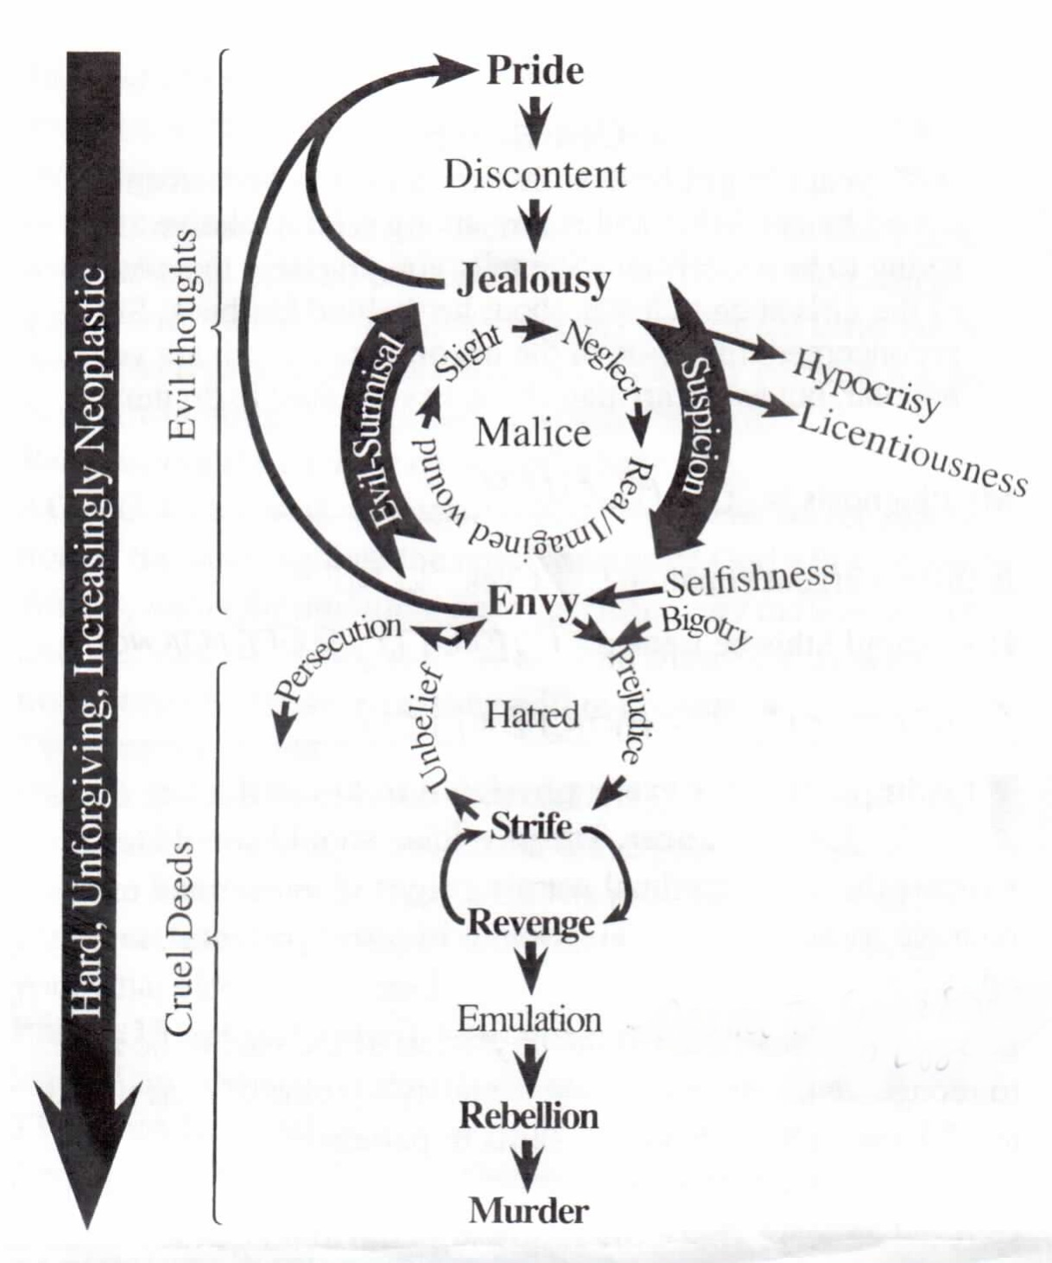
 | Jealousy | Envy
Definition | Thinking I am not regarded highly enough | Thinking that another is too highly regarded
Signs/Symptoms | We reveal jealousy by puffing ourselves subtly or overtly | We reveal envy by speaking evil of others, attempting to diminish their influence, subtly or overtly
Scripture | 1 Cor. 13:4 “Charity (love) suffereth long, [and] is kind; charity envieth not; charity vaunteth not itself, is not puffed up,” | 1 Peter 2:1 “Wherefore laying aside all malice, and all guile, and hypocrisies, and envies, and all evil speakings,”

“There is in the nature of man, when not under the direct influence of the Spirit of God, a disposition to envy, jealousy, and cruel distrust, which, if not subdued, will lead to a desire to undermine and tear down others, while selfish spirits will seek to build themselves up upon their ruins.” {3T 343.2}

“Envy is the offspring of pride, and, if it is entertained in the heart, it will lead to cruel deeds, to hatred, revenge, and murder. The great controversy between Christ and the prince of darkness, is carried on in everyday, practical life.” (ST Aug. 17, 1888). {3BC 1159.7}

After the murder of Christ the Jews were controlled by Satan and in Jerusalem prior to its destruction in AD 70:
“… controlled by impulse and blind rage. They became satanic in their cruelty. …there was suspicion, envy, hatred, strife, rebellion, murder.” {GC 28.1}

Proverb 13:10 “Only by pride cometh contention: …”

“I have been shown that many are cherishing an unholy desire for the supremacy. Many love to be flattered and are jealously watching for slights or neglect. There is a hard, unforgiving spirit. There is envy, strife, emulation.” {5T 50.1} Note- emulation is the desire to not only win, but to cause someone else to lose. It is glorying not only in your win, but in the other’s loss. There is a ruin mentality.

What causes discontent?
- The desire of praise. “For they loved the praise of men more than the praise of God.” John 12:43
- The desire for supremacy. “At the same time came the disciples unto Jesus, saying, Who is the greatest in the kingdom of heaven?” Mat, 18:1

Note - These two desires, the desire of praise and the desire for supremacy, make us believe we are slighted or neglected and because of slights and or neglect we feel wounded. Our wounds may be real or imaginary or greatly exaggerated.

WAYS WE ARE WOUNDED
WOUND | TREATMENT
Imaginary | Treat as real
Self-inflicted (Sinning) | Confession – Prov 28:13; 1 John 1:9
Accidental | Excuse - Mat. 26:41 - Learn Carefulness – prevention
Vengeful/Purposeful | Accept the sovereignity of God and forgive – Gen 25:50; Luke 23:34; Mat. 6:12
Reproof | Welcome reproof – Ps. 141:5

The Secret of Greatly Lessening Our Difficulties
“The difficulties we have to encounter may be very much lessened by that meekness which hides itself in Christ. If we possess the humility of our Master, we shall rise above the slights, the rebuffs, the annoyances, to which we are daily exposed, and they will cease to cast a gloom over the spirit. The highest evidence of nobility in a Christian is self-control. He who under abuse or cruelty fails to maintain a calm and trustful spirit robs God of His right to reveal in him His own perfection of character. Lowliness of heart is the strength that gives victory to the followers of Christ; it is the token of their connection with the courts above.” {DA 301.3}

Recognize early diagnostic signs – Early wounds, complaints, murmuring, annoyance, impatience
Recognize late diagnostic signs – Putrifying sores (Isa. 1:6); insult/slander (Prov 18:8; 16:27); anger (Psalm 37:8); “party” spirit (1 Cor. 1:10-22).

Understanding the typical “metastatic” process
Heart (thoughts) → Liver (feelings) → Kidneys (emotions) → eyes/ears (see and hear) → bowels (compassion) → oral – ear (person to person spreads)

Case Study: Lucifer
Began with pride and the desire to be supreme:
"Why," questioned this mighty angel, "should Christ have the supremacy? Why is He honored above Lucifer?" {PP 36.3}

Then came the inevitable discontent:
“The spirit of discontent and disaffection had never before been known in heaven. It was a new element, strange, mysterious, unaccountable. Lucifer himself had not at first been acquainted with the real nature of his feelings; for a time he had feared to express the workings and imaginings of his mind; yet he did not dismiss them.” {PP 39.1}
This is an early metaplastic change with breach of the immune system.
metaplastic (Transformation of cells from a normal to an abnormal state)

This is an ineffectual process:
ineffectual (lacking in power or forcefulness; impotent)
“Lucifer went forth to diffuse the spirit of discontent among the angels.” {PP 37.1}
Beware of all movements demanding rights!
“Taking advantage of the loving, loyal trust reposed in him by the holy beings under his command, he had so artfully instilled into their minds his own distrust and discontent that his agency was not discerned. Lucifer had presented the purposes of God in a false light--misconstruing and distorting them to excite dissent and dissatisfaction. He cunningly drew his hearers on to give utterance to their feelings; then these expressions were repeated by him when it would serve his purpose, as evidence that the angels were not fully in harmony with the government of God. While claiming for himself perfect loyalty to God, he urged that changes in the order and laws of heaven were necessary for the stability of the divine government. Thus while working to excite opposition to the law of God and to instill his own discontent into the minds of the angels under him, he was ostensibly seeking to remove dissatisfaction and to reconcile disaffected angels to the order of heaven. While secretly fomenting discord and rebellion, he with consummate craft caused it to appear as his sole purpose to promote loyalty and to preserve harmony and peace.” {PP 38.2}
“Though he had left his position as covering cherub, yet if he had been willing to return to God, acknowledging the Creator's wisdom, and satisfied to fill the place appointed him in God's great plan, he would have been reinstated in his office. The time had come for a final decision; he must fully yield to the divine sovereignty or place himself in open rebellion. He nearly reached the decision to return, but pride forbade him. It was too great a sacrifice for one who had been so highly honored to confess that he had been in error, that his imaginings were false, and to yield to the authority which he had been working to prove unjust.” {PP 39.1}

Carcinomatous Transformation
“The preference shown to Christ he declared an act of injustice both to himself and to all the heavenly host, and announced that he would no longer submit to this invasion of his rights and theirs.” {PP 40.1}

Ripening Process
“The spirit of disaffection ripened into active revolt.” {PP 41.2}
“Since his fall it has been his object to infuse the same spirit of envy and discontent, the same ambition for position and honor, into the minds of men.” {PP 403.3}

Case Study: Korah
From Pride to Discontent
“Korah was not satisfied with his position. He was connected with the service of the tabernacle, yet he desired to be exalted to the priesthood. ... Korah determined to compel Moses to change the order of things, whereby he should be raised to the dignity of the priesthood… he drew Dathan and Abiram, the descendants of Reuben, into his rebellion. {1SP 296.1}
They reasoned that, being descendants from the eldest sons of Jacob, the chief authority, which Moses usurped, belonged to them;” {1SP 296.2}

From jealousy to rebellion
“Korah, Dathan and Abiram, and two hundred and fifty princes who had joined them, first became jealous, then envious, and next rebellious. They had talked in regard to Moses' position as ruler of the people, until they imagined that it was a very enviable position, which any of them could fill as well as Moses. And they gave themselves up to discontent, until they really deceived themselves, and one another, in thinking that Moses and Aaron had placed themselves in the position which they occupied in Israel.” {1SP 297.1}

Telltale signs of envy and jealousy
“They said that Moses and Aaron exalted themselves above the congregation of the Lord, in taking upon them the priesthood and government, and that this office should not be conferred on their house alone. They said that it was sufficient for them if they were on a level with their brethren; for they were no more holy than the people, who were equally favored with God's peculiar presence and protection. {1SP 297.1}

What are the signs of envy?
“…it was sufficient for them if they were on a level with their brethren; for they were no more holy than the people, …”
This is attempting to diminish Moses and Aaron.

What are the signs of jealousy?
“…the people, who were equally favored with God's peculiar presence and protection.”
Notice the subtle boasting done as flattery. Korah is here raising himself up to the position of Moses and Aaron by exalting everyone to the same position!

The end of rebellion
Numbers 26:9-11 “… Dathan and Abiram, [which were] famous in the congregation, who strove against Moses and against Aaron in the company of Korah, when they strove against the LORD: And the earth opened her mouth, and swallowed them up together with Korah, when that company died, what time the fire devoured two hundred and fifty men: and they became a sign. Notwithstanding the children of Korah died not.”

Recognizing the earliest causes of rebellion
The work of apostasy begins in some secret rebellion of the heart against the requirements of God's law. Unholy desires, unlawful ambitions, are cherished and indulged, and unbelief and darkness separate the soul from God. If we do not overcome these evils they will overcome us. . . . {AG 333.4}

The cure for discontent
“… be content with such things as ye have: for he hath said, I will never leave thee, nor forsake thee.”
Are you satisfied with Jesus?
Are His promises sufficient?
If you have Jesus, if He hasn’t left you, if He hasn’t forsaken you, what else do you need?
Phil. 4:11 “Not that I speak in respect of want: for I have learned, in whatsoever state I am, [therewith] to be content.”
1 Tim. 6:6 “But godliness with contentment is great gain.”

Cancer Free
“Words can not describe the peace and joy possessed by him who takes God at his word. Trials do not disturb him, slights do not vex him. Self is crucified. Day by day his duties may become more taxing, his temptations stronger, his trials more severe; but he does not falter; for he receives strength equal to his need.” YI 6/26/1906

